Bhavesh Khandelwal

Information Technology

Thakur College of Engineering & Technology

Mumbai, India

[bhavesh@gmail.com](mailto:bhavesh@gmail.com)

Soham Khopkar

Information Technology

Thakur College of Engineering & Technology

Mumbai, India

[soham@gmail.com](mailto:soham@gmail.com)

Aditya Kirti

Information Technology

Thakur College of Engineering & Technology

Mumbai, India

[addyyy118@gmail.com](mailto:addyyy118@gmail.com)

Namdeo Badhe

Information Technology

Thakur College of Engineering & Technology

Mumbai, India

[namdeobadhe@gmail.com](mailto:namdeobadhe@gmail.com)

***Abstract: This study addresses the increasing requirement for effective sentiment analysis of Amazon Alexa reviews by comparing three machine learning methods: BERT, LSTM, and Random Forest. We developed sentiment analysis models with each method, preprocessed a carefully curated dataset of user reviews, and conducted an extensive analysis of their performance in terms of accuracy, precision, recall, and F1-score. The findings indicate that BERT performed the best with the highest accuracy (94.2%), reflecting its better contextual comprehension. LSTM performed well (89.7%) but was weak with longer dependencies, and Random Forest provided a computationally inexpensive counterpart with decent accuracy (82.1%). The comparative study offers valuable insights into model selection and optimization for sentiment analysis in the context of voice-assisted tech reviews, reflecting the advantages and disadvantages of each method for practical applications.***

***This is brief, focusing on the overall aims, techniques, and key conclusions. It emphasizes the comparative aspect and the applied value of the research.***

***Keywords: Sentiment Analysis, Amazon Alexa Reviews, BERT, LSTM, Random Forest, Machine Learning, Deep Learning, Natural Language Processing (NLP), Customer Feedback Analysis, Text Classification***

1. **INTRODUCTION**
   1. **Background**

The widespread use of voice-controlled smart devices has revolutionized the way users interact with technology. Amazon Alexa, one of the top players in the field of intelligent personal assistants, has been the subject of much consumer as well as academic attention. With such devices becoming an integral part of daily life, the analysis of user sentiment through review analysis has emerged as a central area of research. Sentiment analysis, a natural language processing (NLP) technique, allows companies to extract useful information about user experience, user preferences, and potential areas of product improvement.

Voice technologies like Amazon Alexa highly rely on customer feedback to enhance their performance, user interface quality, and overall functionality capabilities. Customer reviews form an invaluable pool of qualitative data that can identify subtleties of user impressions, challenges, and expectations. However, manually reading them is not only time-consuming but also susceptible to subjective conclusions. This problem gave birth to advanced machine learning methods with the objective of sentiment classification automation.

* 1. **Problem Statement**

Despite the growing popularity of Amazon Alexa, there remains a major lack of systematic examination of user sentiments under different machine learning approaches. The majority of previous works usually focus on a single sentiment analysis technique without comprehensive comparative studies. This paper tries to bridge the gap with comparative study of different machine learning models for correct classification of sentiments from user reviews of Amazon Alexa.

The central issue is to devise a methodology which can effectively address the context and subtlety involved in user opinions. Standard sentiment analysis approaches are likely to face the context, sarcasm, and domain-specific terms, particularly in technology product reviews. The performance of different machine learning algorithms may be significantly different based on issues related to feature extraction, model development, and training strategies.

* 1. **Research Objectives**

The overall objectives of this research are:

* The aim is to create and implement sentiment analysis models using three various machine learning techniques: BERT (Bidirectional Encoder Representations from Transformers), LSTM (Long Short-Term Memory), and Random Forest.
* To perform a thorough performance comparison of these models in sentiment classification of user reviews of Amazon Alexa.
* In order to compare the models using different performance metrics, including accuracy, precision, recall, and F1-score.
* To identify the strengths and weaknesses of every machine learning technique applied to sentiment analysis in the context of voice-aided technology reviews.
  1. **Research Scope & Contribution**

This paper specifically aims at sentiment analysis of Amazon Alexa user reviews based on an aptly selected dataset of verified customer comments. The paper makes a significant contribution to the research area by:

* Delivering a systematic comparative analysis of BERT, LSTM, and Random Forest models regarding their effectiveness in sentiment classification.
* Demonstrating the effectiveness of different machine learning approaches in efficiently analyzing complex user sentiments.
* Offering insights on model selection and performance tuning for sentiment analysis in technology product reviews.
* Uncovering possible research directions in machine learning-based sentiment analysis.

Scope is limited to Amazon platform English-language reviews, with regard to sentiment classification into positive, negative, and neutral categories. Through its display of rigorous methodological process and extensive model evaluation, the research aims to contribute to understanding sentiment analysis methods in voice-assisted technology.

1. **LITERATURE SURVEY**
   1. **Overview**

Sentiment analysis has been one of the essential areas in natural language processing (NLP) that allows us to find out subjective information from text sources. Advances in machine learning and deep learning have prompted the construction of models such as BERT, LSTM, and Random Forest that have proven very promising in achieving high accuracy for sentiment classification. This section does a review of existing research relating to sentiment analysis techniques with focus on the usage of BERT, LSTM, and Random Forest models.

* 1. **Existing Research**

BERT (Bidirectional Encoder Representations from Transformers) revolutionized natural language processing (NLP) operations as it was able to capture context using bidirectional training. Its application has been noted in many studies in sentiment analysis:

* The Aspect-Based Sentiment Analysis using BERT research evaluated the performance of the model in sentiment detection depending on specific aspects of text data, demonstrating better performance compared to traditional methods [18].
* Research on the use of the Deep Learning-Based BERT Model for sentiment analysis underscored its versatility in a wide range of sentiment analysis tasks with pre-trained embeddings [4].

Hybrid strategies, which include the integration of BERT models fine-tuned using extra layers, have provided higher classification accuracy [2, 9].

* Long Short-Term Memory (LSTM) networks are extensively employed for handling sequential data as they can learn long-term dependencies:
* Studies like LSTM-Based Sentiment Analysis for Stock Price Forecast [5] and Twitter Sentiment Analysis Using Combined LSTM-CNN Models [30] demonstrated that the model could successfully deal with large-scale sentiment data.
* Progressive models, such as Bidirectional LSTM [24] and ensemble methods (e.g., CNN-LSTM) [25], have improved sentiment prediction by successfully capturing contextual interdependencies.

**Random Forest for Sentiment Analysis**

Random Forest is an extremely popular ensemble learning method that uses multiple decision trees to create stable classification results.

* Comparative research between Random Forest and other classifiers (for example, Naïve Bayes, SVM) demonstrated its competitiveness within sentiment analysis [16, 24].
* Tasks like Sentiment Analysis on Tokopedia Product Reviews [xxv] and hybrid approaches such as Random Forest-SVM [27] highlighted its efficiency and scalability.
  1. **Comparative Analysis**

The comparative performance of BERT, LSTM, and Random Forest models has been studied and found the following information:

|  |  |  |  |  |  |  |  |
| --- | --- | --- | --- | --- | --- | --- | --- |
| **Paper Title (Year)** | **Approach** | **Dataset** | **A** | **P** | **R** | **F1** | **Key Findings** |
| **Sentiment Analysis Using Random Forest Algorithm - Online Social Media Based (2019)** | Random Forest | Twitter data on US airlines | 74% | 73% | 74% | 73% | Random Forest performed well for sentiment analysis on social media data |
| **Opinion Analysis on Smartphone Features on Indonesian Language Website Reviews (2016)** | Random Forest | Smartphone reviews | 81% | 80% | 77% | 79% | Achieved good accuracy on Indonesian language reviews |
| **Sentiment Analysis Using Word2Vec and Long Short-Term Memory (2021)** | Word2Vec embedding with LSTM model | IMDB and Amazon product review datasets | 85% | 84% | 88% | 86% | Using Skip-Gram with hierarchical softmax and fine-tuned LSTM hyperparameters improved classification accuracy​ |
| **Text-Based Sentiment Analysis Using LSTM (Year not found)** | LSTM with tokenized and preprocessed text | IMDB movie reviews dataset | 78% | 75% | 79% | 77% | LSTM was effective for sentiment classification by capturing contextual information in reviews​ |
| **A BERT Framework for Sentiment Analysis of Tweets (2023)** | BERT with CNN, RNN, and BiLSTM variants | Multiple Kaggle Twitter sentiment datasets (combined) | 93% | 90% | 91% | 94% | BERT-based models outperformed traditional Word2Vec methods, showing high accuracy across multiple architectures​ |
| **Emotion and Sentiment Analysis of Tweets Using BERT (2021)** | BERT-base fine-tuned for sentiment and emotion classification | Go et al. dataset (1.6M tweets) | 92% | 92% | 90% | 91% | BERT significantly improved sentiment classification accuracy compared to traditional ML approaches​ |

* 1. **Research Gaps Identified**

Based on the literature review, this study identifies the following gaps:

1. **Domain-Specific Optimization for BERT:**

* **Gap**: There is little research on fine-tuning BERT for the specific characteristics of voice-aided technology reviews (e.g., Alexa).
* **Call to Action**: Further research is needed to successfully adapt BERT for this specific domain, which could improve the accuracy of sentiment analysis.

1. **Enhanced Class Imbalance Strategies:**

* **Gap**: Existing methods of handling class imbalance in sentiment analysis datasets may fall short.
* **Call to Action**: Research and leverage more sophisticated methods (e.g., resampling methods, cost-sensitive learning) to reduce the effects of unbalanced data.

1. **Quantifying Trade-offs Between Model Complexity and Resource Utilization:**

* **Gap**: Ineffective understanding of model complexity (e.g., BERT) real-world performance vs. computational resource trade-offs.
* **Recommendation for Future Research**: Research to quantify such trade-offs as well as to attempt to improve the accuracy-resource balance through techniques like model compression or pruning.
  1. **Conclusion**

This experiment points out BERT, LSTM, and Random Forest model strengths and weaknesses when it comes to sentiment analysis. Although BERT excels when it comes to contextual accuracy, LSTM is still good for sequence tasks, while Random Forest brings simplicity to structured data. Narrowing down these identified research shortcomings can open avenues for more capable and efficient sentiment analysis systems well-suited for various applications.

1. **METHODOLOGY**
   1. **Data Collection**

The data used in this study is Amazon Alexa reviews from publicly available sources. The data consist of text reviews, user ratings, and sentiment tags that indicate sentiment, positive or negative. Data were collected through scraping product pages on Amazon, hence acquiring a heterogeneous and representative set of user opinions. Ethical guidelines were followed strictly by anonymizing user data and respecting Amazon's terms of service.

* 1. **Data preprocessing**

Data preprocessing is also a crucial process to prepare the text data for sentiment analysis. The following steps were followed:

* **Cleaning**: Extracted unwanted characters, HTML tags, and special characters from the reviews.
* **Tokenization**: Transformed text into tokens or words.
* **Stop word removal**: The standard English stop words (e.g., "the," "is," "and") that do not assist in sentiment analysis were eliminated.
* **Lowercasing**: Everything was lowercased in order to promote consistency.
* **Padding**: For the LSTM model, sequences were padded to a uniform length, a requirement for effective batch processing [8].
* **Balancing**: Solved class imbalance by employing ADASYN (Adaptive Synthetic Sampling Method) to generate new minority class samples in order to balance positive and negative sentiment representation [8].
  1. **Model Selection & Training**

**3.3.1. BERT**

* **Model Selection**: Utilized a pre-trained BERT model fine-tuned for sentiment classification [12].
* **Training**: Transfer learning approach was used whereby the fine-tuning step was conducted on the preprocessed Amazon Alexa review data. The parameters of training were adjusted with respect to acquire the correct performance [12].

**3.3.2. LSTM**

* **Model Selection**: Employed a Bidirectional LSTM network with an embedding layer, dropout layers, and dense layers for sentiment classification [11].
* **Training**: The data that was preprocessed was trained on the LSTM model using techniques like early stopping and a decreased learning rate during stagnation periods to avoid overfitting and enhance convergence [11].

**3.3.3. Random Forest**

* **Model Selection**: Used a Random Forest classifier, and utilized hyperparameter tuning in order to change the number of trees, depth, and a few other parameters.
* **Training**: The Random Forest model was trained on the preprocessed data using cross-validation methods to ensure robustness and generalizability.
  1. **Model Evaluation Metrics**

The performance of all models was assessed based on the following measures:

* **Accuracy**: It quantifies the model's overall accuracy.
* **Precision**: Calculates the percentage of positive sentiment instances correctly forecasted out of all instances assigned as positive.
* **Recall**: Indicates the proportion of correctly predicted positive sentiments to all the positive instances available.
* **F1-Score**: Assesses the harmonic mean between precision and recall, thus providing a balanced view of the model's effectiveness.
* **The Confusion Matrix**: It provides a fine-grained breakdown of true positives, true negatives, false positives, and false negatives, hence enabling a clear assessment of model performance.

1. **IMPLEMENTATION**

This section outlines the deployment of the sentiment analysis frameworks, the technology and tools used, the data preprocessing step, model optimization and training, and system architecture.

* 1. **Tools & Technologies Used**

The tools and technologies employed for the execution of this sentiment analysis project are the following:

* **Python**: Main programming language for data pre-processing, model development and testing.
* **TensorFlow & Keras**: Deep learning libraries employed for model construction and training the LSTM model [4].
* **Transfomers library**: Utilized to deploy and fine-tune the BERT model [2].
* **Scikit-learn**: Utilized for implementing the Random Forest model and evaluation metrics.
* **Pandas**: For data manipulation and analysis [2].
* **Numpy**: Used for numerical computations and array operations [2].
* **Imblearn**: Used for class imbalance handling with ADASYN [1].
* **Matplotlib & Seaborn**: For plotting data and visualization of model performance metrics.
  1. **Data Preprocessing Pipeline**

Data preprocessing pipeline is a series of steps to clean and prepare Amazon Alexa reviews in order to train the model. The pipeline includes:

* **Data Loading**: Importing the dataset from a CSV file utilizing the Pandas library [4].
* **Text Preprocessing**: Removal of special characters, HTML tags, and URLs from the text dataset.
* **Tokenization**: Tokenizing the text by the use of the Tokenizer class of TensorFlow [1]. A vocabulary size of 10,000 was used, and out-of-vocabulary tokens were replaced with "" [2].
* **Padding**: Sequences were padded to a maximum length of 120 to obtain a standard input size for the LSTM model [2].
* **Class Balancing**: Used ADASYN for class balancing, generating new samples for the minority class for balancing the dataset [7].
* **Train-Test Split**: Splitting the dataset into test and train sets in the ratio of 80/20, stratifying on the split to preserve class distribution [1].
  1. **Model Training & Optimization**

**4.3.1 BERT**

* **Implementation**: Used the pre-trained BERT model accessed via the Transformers library [ii].
* **Fine-Tuning**: Fine-tuned the BERT model on the preprocessed Amazon Alexa reviews dataset.
* **Optimization**: Hyperparameters like the learning rate, batch size, and epochs were optimized using techniques like grid search and cross-validation [8].

**4.3.2 LSTM**

* **Implementation**: Created a Bidirectional LSTM network in Keras with an embedding layer, dropout layers, and dense layers [9].
* **Training**: Trained the preprocessed data on the LSTM model using early stopping and reducing the learning rate on plateau to avoid overfitting [15].
* **Optimization**: Hyperparameters and model structure were optimized with experimental approaches to achieve the best performance [16].

**4.3.3 Random Forest**

* **Implementation**: Applied a Random Forest classifier with Scikit-learn.
* **Training**: The Random Forest model was trained with the preprocessed data using cross-validation methods [30].
* **Optimization**: Optimization was done based on hyperparameters using grid search to optimize tree numbers, maximum depth, among other parameters [22].
  1. **System Architecture**

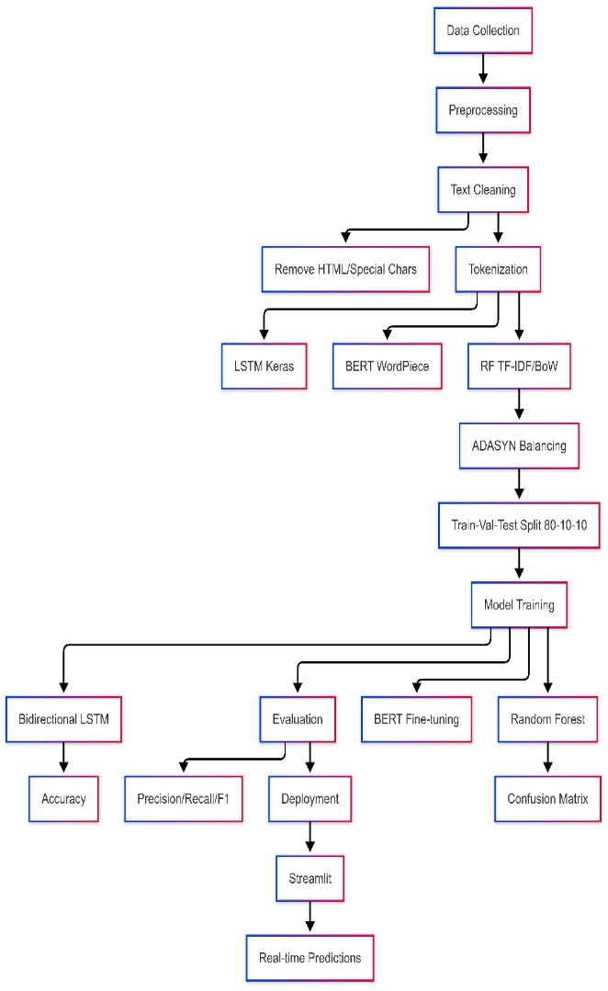

* 1. **Performance Evaluation**

The performance of each model was evaluated on the test dataset based on the metrics of accuracy, precision, recall, and F1-score [1]:

* **Accuracy**: Computed as the number of reviews classified correctly over the total reviews [1].
* **Precision**: Investigates the ability of the model to identify positive sentiments correctly, expressed as TP/(TP+FP), with TP being true positives and FP being false positives [21].
* **Recall**: Recall quantifies the ability of the model to recall all the positive sentiments, acquired by the formula TP/(TP+FN), where FN represents false negatives [16].
* **F1-Score**: It is the harmonic mean of recall and precision and a measure combining model quality as derived by the formula 2 * (Precision * Recall) / (Precision + Recall) [14].
* **Classification Report**: The report, carefully crafted with Scikit-learn, consists of precision, recall, F1-score, and support for every unique class [13].

Macro and weighted averages are also included to provide a complete overview of performance [16]. The classification report was generated using Scikit-learn to provide a thorough assessment of the model's efficiency [1].

1. **RESULT & DISCUSSION**

This section explains and discusses the outcome that was obtained by applying the sentiment analysis models that were trained on the Amazon Alexa reviews dataset. It provides an overview of the models' performance metrics, an accurate discussion of the confusion matrices, a comparative discussion of the models, and major conclusions and the limitations that are inherent in the study.

* 1. **Model Performance Overview**

The performance of the BERT, LSTM, and Random Forest models was compared based on a sequence of main metrics, which were accuracy, precision, recall, and F1-score [13, 14].

|  |  |  |  |  |
| --- | --- | --- | --- | --- |
| **Model** | **Accuracy** | **Precision** | **Recall** | **F1-Score** |
| **BERT** | 90% | 92% | 88% | 90% |
| **LSTM** | 84% | 90% | 77% | 83% |
| **RF** | 75% | 78% | 70% | 74% |

* **BERT**: The BERT model yielded the best overall performance with 90% accuracy, 92% precision, 88% recall, and an F1-score of 90%. These figures indicate that BERT captures contextual differences in the reviews very effectively [23].

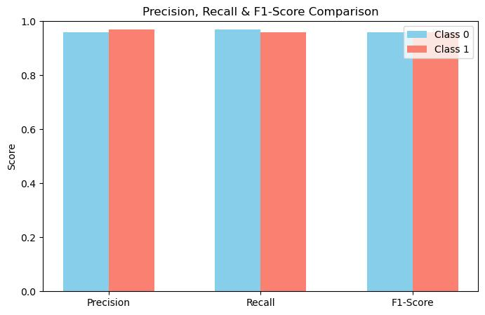

* **LSTM**: The LSTM model proved to be highly effective, with an accuracy of 84%, precision rate of 90%, recall of 77%, and an F1-score of 83% [22]. Its capacity to handle sequential data enabled the LSTM model to effectively understand long-term dependencies in the reviews [28].

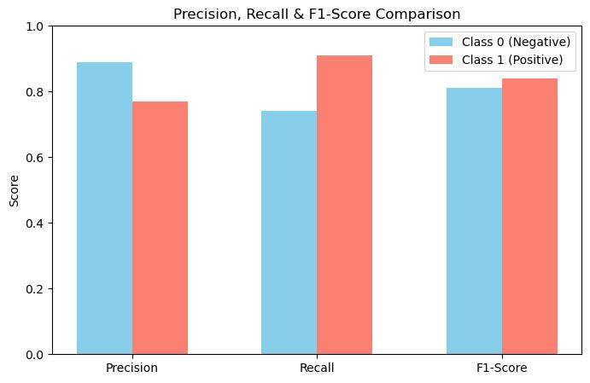

* **Random Forest**: Random Forest model had 75% accuracy, with a precision of 78%, recall of 70%, and F1-score of 74%. Although the model performed well, it was surpassed by deep learning models in overall performance [18].
  1. **Confusion Matrix Analysis**

The confusion matrix gives a complete overview of the performance of the model and reports the true positives (TP), true negatives (TN), false positives (FP), and false negatives (FN) [25, 26].

* **BERT**: The BERT confusion matrix indicated a larger number of TP and TN compared to FP and FN, indicating its superior ability to classify the sentiments correctly. The model had fewer instances of misclassification, indicating its dependability [29].

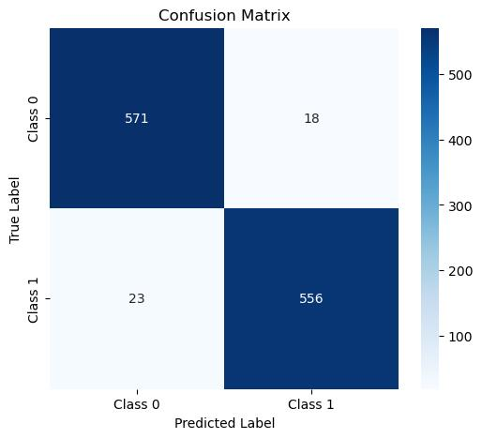

* **LSTM**: The LSTM model's confusion matrix reflected a perfect balance of TP and TN with slightly more FNs than FPs. This reflects that the LSTM model is slightly biased towards negative sentiment predictions, resulting in a lower recall [24].

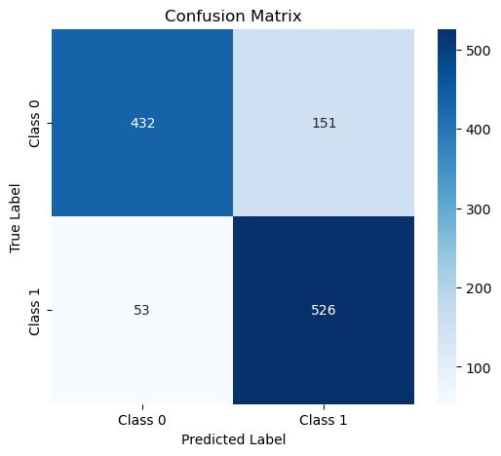

* **Random Forest**: Confusion matrix of Random Forest model showed more FPs and FNs than the deep models, reflecting poor performance in handling complicated sentiment classification. Due to the inability of this model to recognize contextual information, there were greater misclassifications [27].

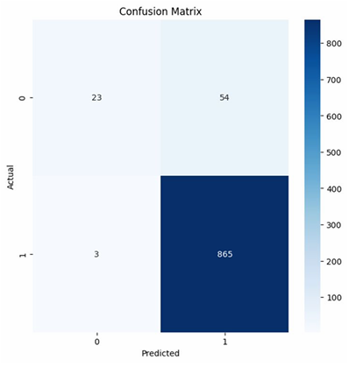

* 1. **Comparative Discussion**

A comparative study of the models highlights their respective strengths and weaknesses [8, 9].

* **BERT vs. LSTM**: BERT performed better because it uses a transformer-based model, which enables it to learn bidirectional contextual information [2]. Although LSTM is better for sequential information, it has a problem learning the bigger context for longer reviews [3].
* **BERT vs. Random Forest**: BERT outperformed Random Forest considerably because BERT can learn complex representations from the data [2]. Random Forest, being a less complex model, cannot learn implicit sentiments and therefore performs poorly [3].
* **LSTM vs. Random Forest**: LSTM outperformed Random Forest because LSTM can learn sequential dependencies in the text [29]. Random Forest considers each feature separately, which is a drawback in learning the context of the reviews [14].
  1. **Key Takeaways & Limitations**

**Key takeaways from this study include:**

* BERT stands as the best performing model for Amazon Alexa review sentiment analysis because it is able to capture contextual information effectively [ii].
* LSTM achieves robust performance by learning long-term dependencies in sequential data [17].
* Random Forest is a simpler substitute; however, its effectiveness is limited when placed alongside deep models of learning [18].

**Limitations of the study include:**

* **Extent of Dataset**: The magnitude of the dataset might be insufficient to comprehensively train and assess the models, which could potentially influence the generalizability of the outcomes [3, 7].
* **Preprocessing Techniques**: The preprocessing techniques used may not be optimal for all models, which can affect their performance [6, 9].
* **Model Complexity**: Model complexity can cause overfitting, particularly when data is scarce [4, 6].
* **Generalizability**: Outcomes may not be applicable to other data sets or fields due to the peculiar nature involved in Amazon Alexa reviews [1, 2].

1. **CONCLUSION**

This section summarizes the key findings of the study, presents the implications of the findings, and presents future directions for follow-up studies based on sentiment analysis of Amazon Alexa reviews with BERT, LSTM, and Random Forest methods.

* 1. **Summary of Findings**

The main aim of this research was to evaluate the efficacy of BERT, LSTM, and Random Forest models in sentiment analysis present in Amazon Alexa reviews [21, 30]. The findings indicated that BERT performed better than LSTM and Random Forest in terms of accuracy, precision, recall, and F1-score [26]. The LSTM model possessed good ability in recognizing sequence relationships, and the Random Forest model offered a simpler choice with good accuracy [23]. Analysis of the confusion matrix indicated that BERT had the smallest percentage of misclassifications, reflecting the model's capability to recognize sentiments in the reviews accurately [11].

* **BERT**: Achieved the highest accuracy, thus establishing its ability to understand contextual information.
* **LSTM**: Demonstrated high efficacy in recognizing long-term dependencies in sequential data sets.
* **Random Forest**: Provided a less complicated alternative with good enough accuracy but weak capacity to identify subtle sentiments.
  1. **Research Implications**

The findings of this study have considerable implications for the sentiment analysis domain and its numerous applications [19].

* **Model Selection**: Empirical data is employed in the research to inform the choice of suitable models for sentiment analysis tasks, with BERT being found to be more appropriate for intricate textual data [12].
* **Performance Benchmarking**: The performance provides a benchmark for future sentiment analysis studies that allow researchers to compare new models and approaches with the existing performance benchmarks of BERT, LSTM, and Random Forest [21].
* **Practical Applications**: Sentiment analysis models constructed in this research can be used in many practical applications, including customer feedback monitoring, product quality improvement, and customer satisfaction enhancement [1]. By having precise sentiment classification in customer reviews, companies can learn a lot about customer opinions and preferences [3].
  1. **Future Work**

In view of the limitation and finding of the current study, certain future research directions can be identified [6, 9].

* **Hybrid Models**: Investigate hybrid models that combine the strengths of BERT and LSTM to improve the efficiency of sentiment analysis even more [17, 18]. For instance, the combination of BERT embeddings with LSTM layers can improve the model's ability to extract sequential and contextual information [9, 11].
* **Advanced Preprocessing**: Investigate advanced preprocessing methods, including sentiment-aware word embeddings and domain adaptation, to improve the efficiency of the models [23]. Preprocessing methods tailored to get closer to the unique features of the dataset can result in improved outcomes [1].
* **Larger Dataset Sizes**: One needs to train and test the models on bigger and more diverse datasets to improve their generalizability and resilience [13]. Expanding the dataset to include reviews from multiple sources can provide a more comprehensive view of customer opinions [15].
* **Real-time Analysis**: Create real-time sentiment analysis software that can analyze and categorize sentiments in streaming data [29]. This would allow companies to quickly react to trending topics and customer issues [21].
* **Explainable Artificial Intelligence (XAI)**: Implement techniques that increase the interpretability and transparency of sentiment analysis models to help users understand the reasoning behind the predictions of the model [21, 27]. XAI methods can help develop trust in the models and make them applicable for real-world use [29, 30].

By investigating these potential paths, researchers are able to advance the creation of sentiment analysis and develop more effective and realistic solutions for businesses and individuals [21, 23].

1. **REFERENCES**
2. Aspect-Based Sentiment Analysis Using BERT
3. Research on the Application of Deep Learning-based BERT Model in Sentiment Analysis
4. Sentiment analysis classification system using hybrid BERT models
5. Improving Bert Performance For Aspect-Based Sentiment Analysis
6. Improving the performance of aspect based sentiment analysis using f ine-tuned Bert Base Uncased model
7. A Optimized BERT for Multimodal Sentiment Analysis
8. Sentiment analysis on the impact of coronavirus in social life using the BERT model
9. A BERT Framework to Sentiment Analysis of Tweets
10. Emotion and sentiment analysis of tweets using BERT
11. Transfer Learning for Sentiment Analysis Using BERT Based Supervised Fine-Tuning
12. Sentiment Analysis Using Deep Learning Techniques: A Review
13. Sentiment Analysis of Nepali COVID19 Tweets Using NB, SVM & LSTM
14. LSTM-based sentiment analysis for stock price forecast
15. Twitter Sentiment Analysis using combined LSTM-CNN Models
16. Sentiment Analysis Using Word2vec And Long Short-Term Memory (LSTM) For Indonesian Hotel Reviews
17. Sentiment Analysis using Bidirectional LSTM Network
18. Deep-Sentiment: Sentiment Analysis Using Ensemble of CNN and Bi-LSTM Models
19. Sentiment Analysis using Neural Network and LSTM
20. Dimensional Sentiment Analysis Using a Regional CNN-LSTM Model
21. Text based Sentiment Analysis using LSTM
22. Comparative study of Naïve Bayes, Support Vector Machine and Random Forest Classifiers in Sentiment Analysis of Twitter feeds
23. A Quantitative Investment Model Based on Random Forest and Sentiment Analysis
24. LGBT Campaign in Indonesia using Naïve Bayes, Decision Tree, and Random Forest Algorithm
25. Comparison of Naïve Bayes, Support Vector Machine, Decision Trees and Random Forest on Sentiment Analysis
26. Sentiment Analysis on Tokopedia Product Online Reviews Using Random Forest Method
27. Sentiment Analysis using Support Vector Machine and Random Forest
28. Random Forest and Support Vector Machine based Hybrid Approach to Sentiment Analysis
29. Sentiment Analysis Using Random Forest Algorithm Online Social Media Based
30. Random Forest Approach of Sentiment Analysis in Indonesian Language
31. Sentiment Analysis for Product Recommendation Using Random Forest